Gaming Arena
Project Report
Programming Fundamentals
Section: F

Group Members:
23k-0553 Abdul Moiz
23k-0614 Saad Shakeel
23k-0782 Huzaifa Abdul Rehman

FEATURES
Modularity
- The code is well-organized into functions for each game, promoting modularity and readability.
- Functions like Guess, batting, bowling, toss, and max enhance code reusability.
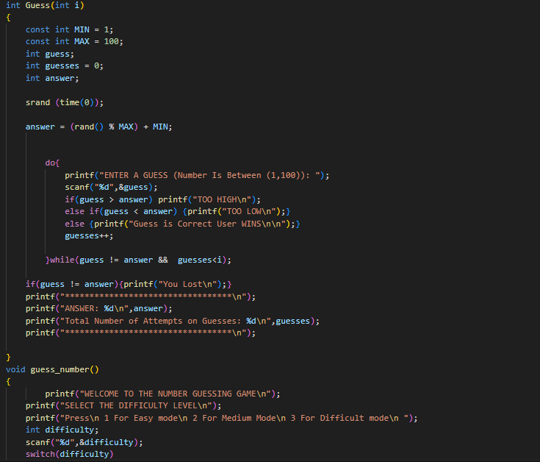

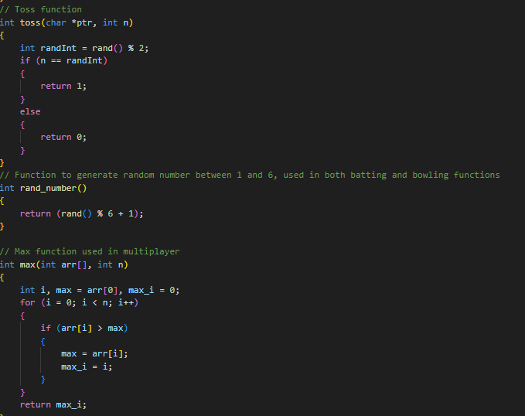

Multiplayer
Both Snake Water Gun and Hand Cricket seamlessly support multiplayer functionality, providing users with options for both solo and competitive gameplay, enriching the overall gaming experience.
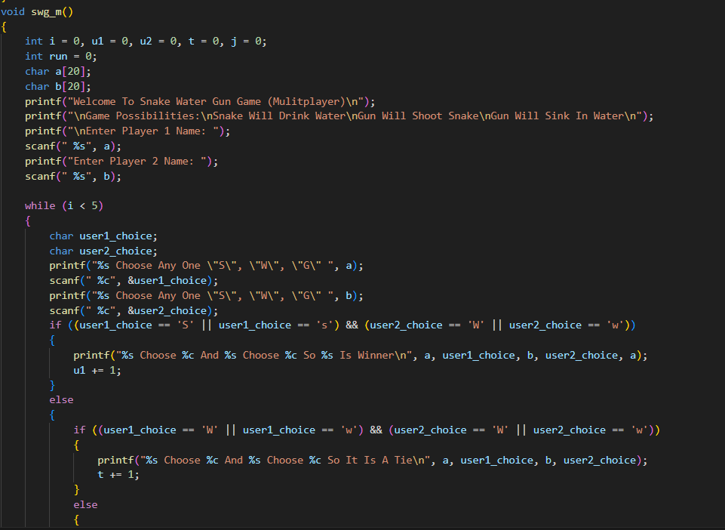

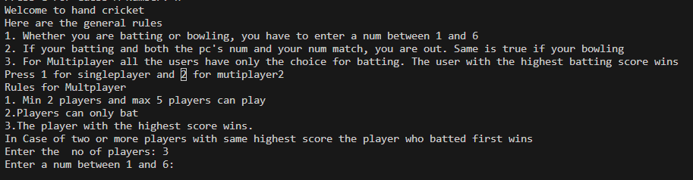

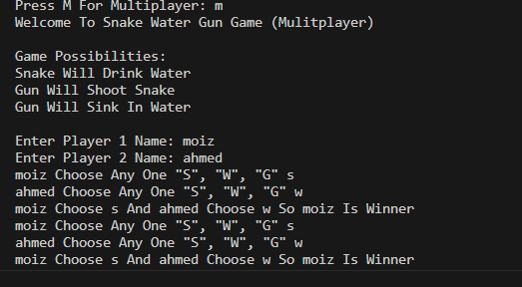

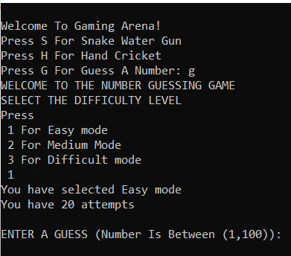
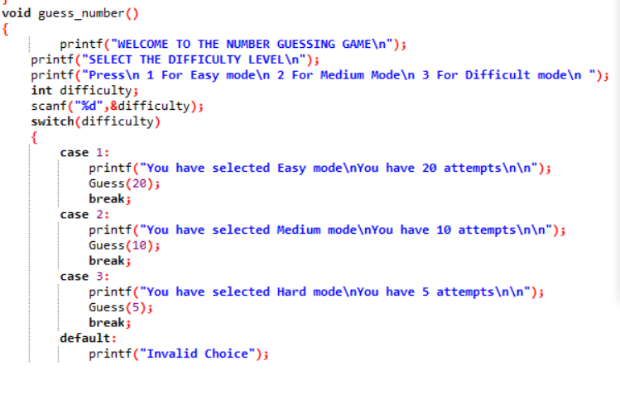
Difficulty Level & Algorithm of Random Function:
The number guessing game has three difficulty levels: Easy, Medium, and Hard. The user has a limited number of attempts to guess the number, and the number of attempts depends on the difficulty level selected by the user. The random number generator algorithm used in the game is based on the rand() function, which generates a random number between 1 and 100. The srand() function is used to seed the random number generator with the current time to ensure that the random numbers generated are different each time the program is run. The project has a modular design, which makes it easy to add new games or modify ex
isting ones.

Feedback & Rating
- We ensure the collection of user feedback regarding their gaming experience.
- Users are encouraged to share their thoughts and suggestions regarding the game.

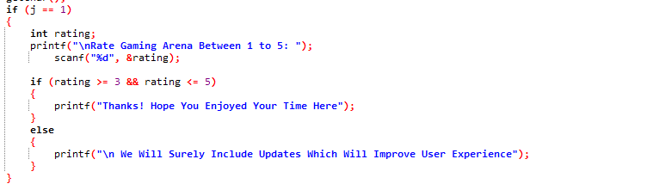
Replay
- Users have been provided with the option to return to the main menu after each play.
- In the event of an incorrect user turn, the system ensures that the turn is not lost, and users are accommodated to replay that specific turn.
